AMITY UNIVERSITY,BENGALURU

SOURCE CODE MANAGEMENT

**Submitted To: Submitted By:**

Dr.Monith Kapoor Deekshith Kumar

**Submission date: Enroll:**A86605224319

02-06-2025 **Course:** Btech-CSE Course slot: L3+4

**Installation and configuration of gitbash and GitHub**

1.Download Git for Windows

Navigate to the official Git website and download the installer for Windows.

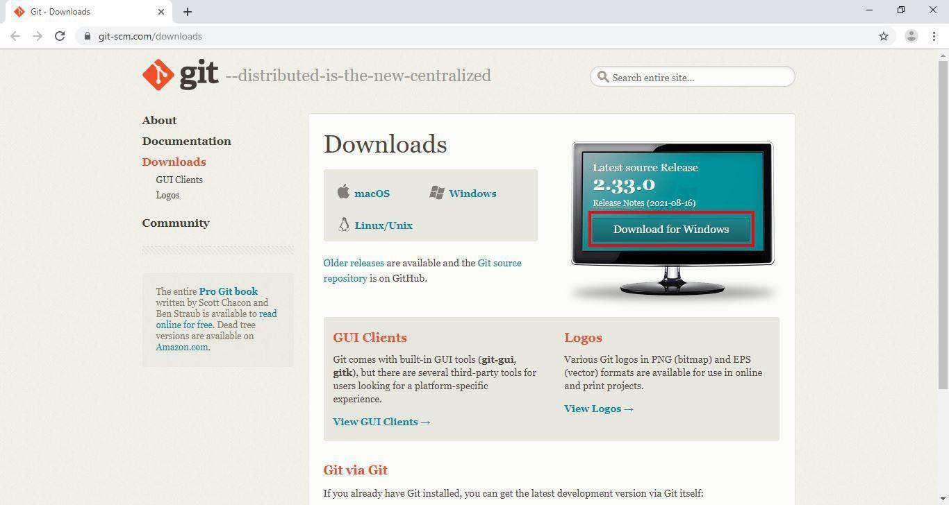

2.License Agreement

Upon running the installer, you'll be presented with the GNU General Public License. Accept the agreement to proceed.

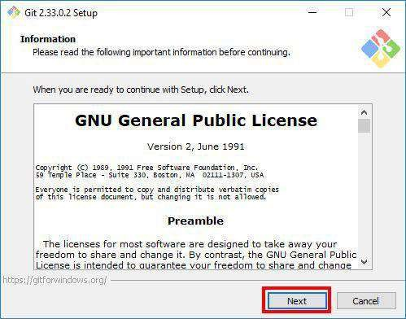

3.Select Installation Folder

Choose the directory where Git will be installed. The default path is usually sufficient.

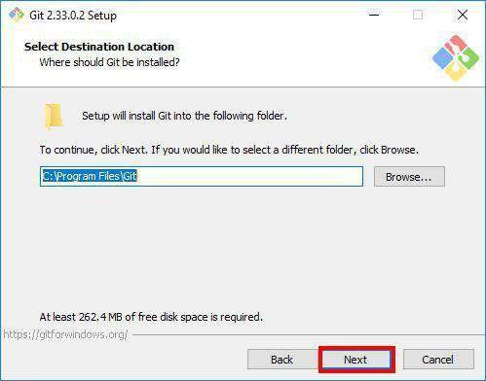

4.Select Components

Select the components you wish to install. It's recommended to leave the default selections unless you have specific requirements.

5.Choose Start Menu Folder

Decide on the Start Menu folder name where Git shortcuts will be placed.

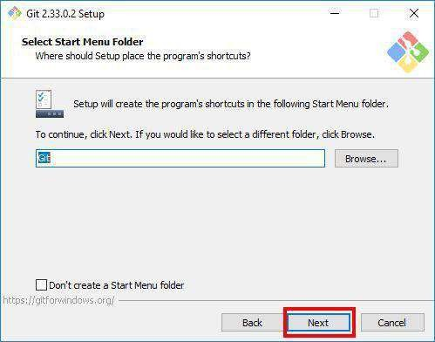

6.Choosing the Default Editor

Select the default text editor for Git. Visual Studio Code is a popular choice.

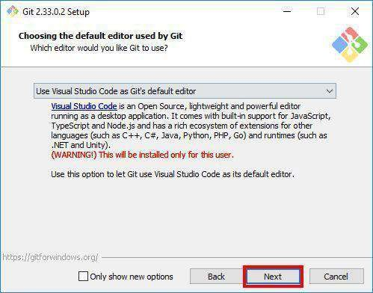

7.Adjusting the Name of the Initial Branch

Set the default branch name for new repositories. "main" is commonly used.

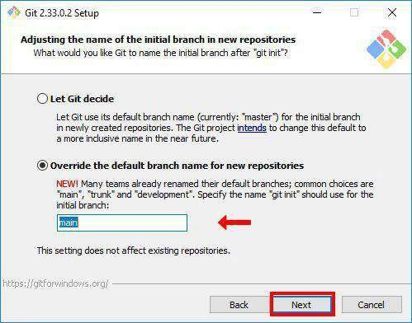

8.Adjusting Your PATH Environment

Choose how Git will be integrated into your system's PATH. The recommended option allows Git to be used from the command line and third-party software.

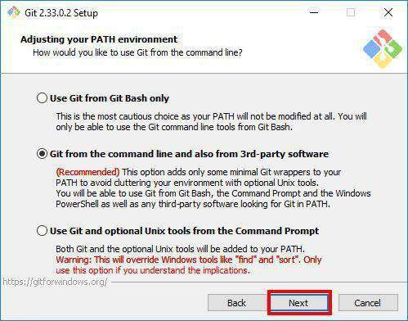

9.Choosing HTTPS Transport Backend

Select the HTTPS transport backend. Using the OpenSSL library is the default and recommended option.

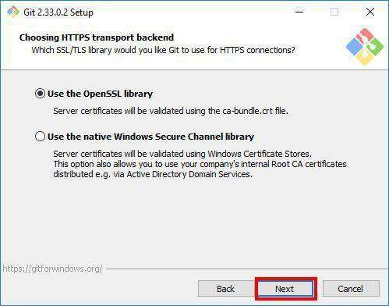

10.Configuring the Line Ending Conversions

Decide how Git will handle line endings. The default setting is suitable for most users.

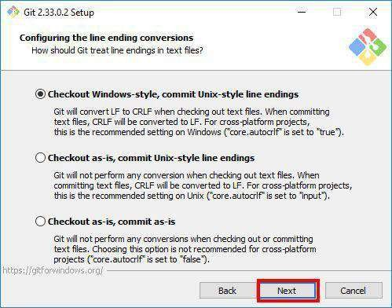

11.Configuring the Terminal Emulator

Choose the terminal emulator for Git Bash. The default MinTTY is recommended.

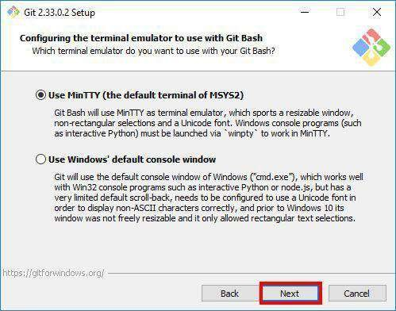

12.Configuring Extra Options

Select any additional options as needed. The defaults are generally appropriate.

13.Installing Git

Click "Install" to begin the installation process.

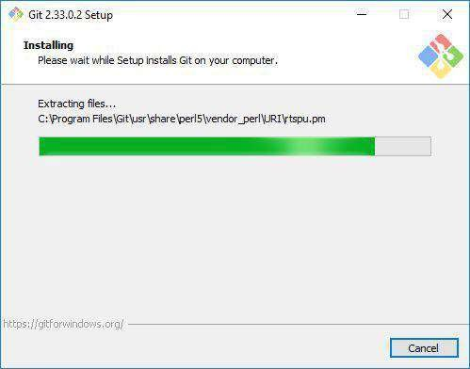

14.Completing the Installation

Once the installation is complete, git bash can be launched .

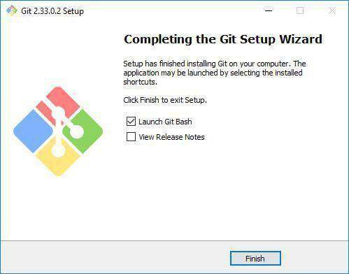

**Setting up Git Environment and Basic Configuration**

**Objective:**

To install Git version control system and configure basic user settings for version control operations.

**Prerequisites:**  
Operating System (Windows/Linux/MacOS)  
Administrator/sudo privileges  
Internet connection for installation

**Environment Details:**  
Operating System: [OS Build 26100.3194)  
Git Version: [git version 2.47.1.windows.2]

**Implementation Steps:** **1. Git Installation:**  
  # Steps used for installation

* Step 1: Download the Git Installer Head over to the official Git website and download the Windows installer. ...
* Step 2: Run the Installer Open the downloaded setup file to launch the installer. ...
* Step 3: Select Installation Preferences Choose your desired options as the wizard prompts you. ...
* Step 4: Complete the Installation Finish the setup by clicking ‘Install.’ ...
* Step 5: Verify the Installation.

**2. Installation Verification:** # Command – [git --version]  
 # Output – [Installation Verification: git version

2.47.1.windows.2]

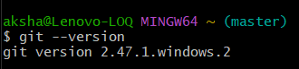

**3. Project Setup:**  
 # Commands – [git init]  
 # Output – [initialized empty Git repository in C:/Users/aksha/.git/]

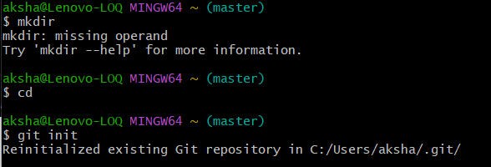

**4. Git Configuration:**

# **Commands** – git config --global user.name”[Deekshith]”

git config --global user.email "[deekshith.kumar@s.amity.edu]"

# **Verification Commands and Outputs**

git config --global user.name

git config --global user.email

Expected Output:

[Deekshith]

[deekshith.kumar@s.amity.edu]



**Challenges Faced:**  
 [ sometimes the version of git is not showing in my friend’s laptop it is not displaying the version of the git instead of that it displaying “command not found” ]

**Learning Outcomes:**  1. Understanding of Git installation process  
  2. Knowledge of basic Git configuration  
  3. Ability to verify Git setup and configuration  
  4. Familiarity with Git command-line interface

**Conclusion:**  
Configured Git for streamlined source code management, for ensuring efficient tracking, collaboration, and version control in development projects.

**CREATING AND MANAGING LOCAL REPOSITORIES**

**OBJECTIVE:**

To create a local repository and understand its basic structure and initialization process.

**PREREQUISITES:**

**1**.GIT

**2.**BASIC COMMAND LINE FAMILIARITY

**3.**PROJECT DIRECTORY FOR FAMILIARITY

**ENVIRONMENTAL DETAILS:**

**1.**Git version: git version 2.47.1.windows.2

**2**.working directory;/c/Users/aksha

**IMPLEMENTATION STEPS:**

1**.**Repository creation

**#commands**

git init

**#output**



**2.REPOSITORY STRUCTURE ANALYSIS**

**#COMMANDS**

cd D:

ls-al

**#output**



**3.Repository status check:**

**#commands**

git status

**#expected output**



**Lab exercise 3: Working with basic git commands(add,commit,status)**

**Objective:**

To understand and practice the basic git commands for staging and committing changes while monitoring repository status

**Prerequisites:**

1.Git repository initialization

2.Basic understanding of git directory structure

**Environment details:**

1.Git version : 2.47.1.windows.2

2.Working directory: /a/sourcecode

**Implementation steps :**

**1.Creating a sample file**

#commands

1.echo "this is my first.".test.txt

2.ls -al

#output

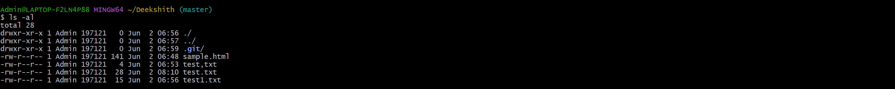

**2.Checking repository status:**

**#commands**

1. git status

**#output**

**3.Adding file to staging area:**

**#command**

1.git add feature1.js

2.git status

**#output**

Merging two branches with and without conflicts and graphing all of them

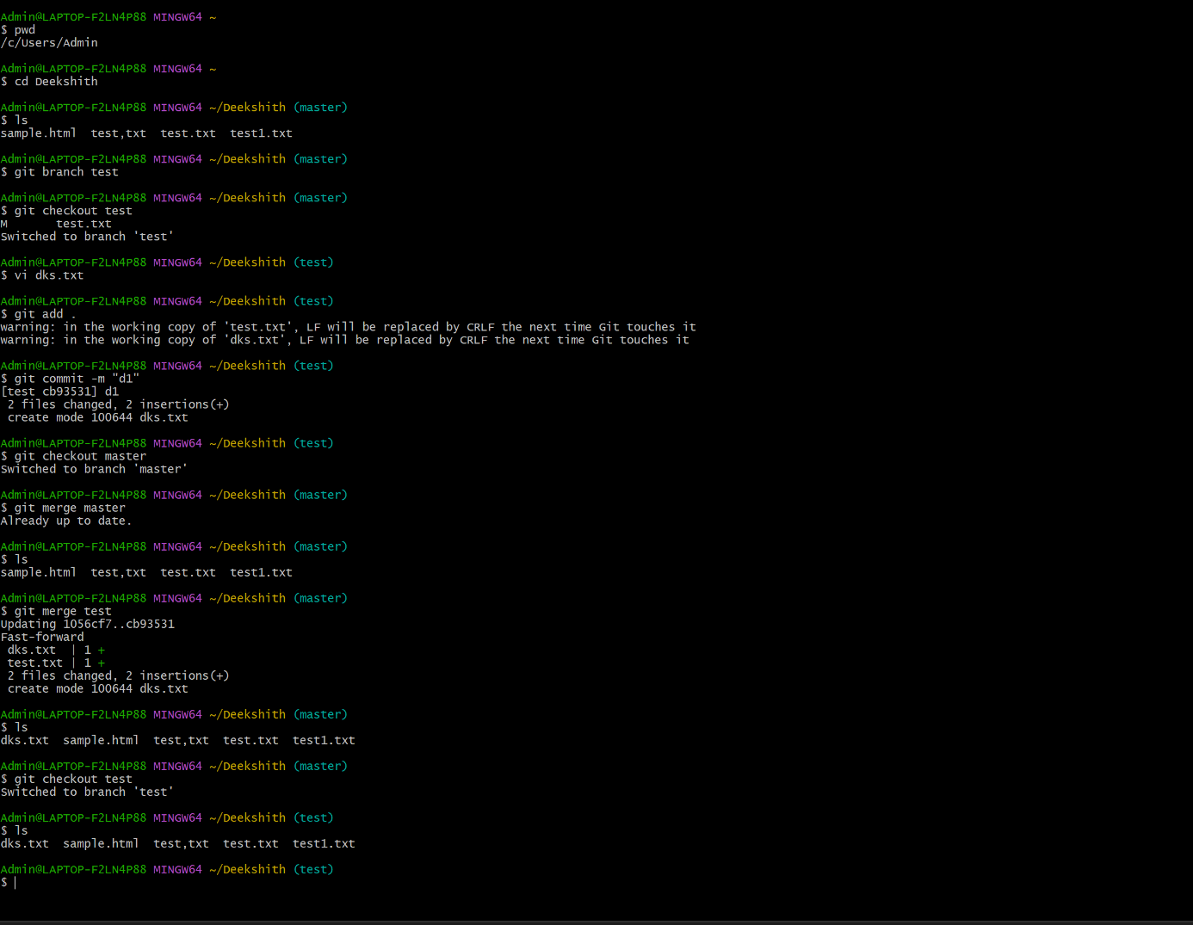

Pull Requests and close in Github

IN GIT-HUB:

